Software Design Document
An AI-Powered Web Application for Skin Cancer Detection
and Cure Recommendation



Submitted by
Abdul Rehman (F22BINFT1M01133)
Submitted to
Dr. Syed Ali Nawaz Shah

Department of Information Technology
Faculty of Computing
The Islamia University of Bahawalpur

Summery
This document presents the Software Design Document (SDD) for an AI-powered web-based Skin Cancer Detection system. Skin cancer is one of the most rapidly increasing diseases worldwide, and early detection plays a crucial role in improving patient survival rates. With advancements in Artificial Intelligence and Deep Learning, automated image-based diagnostic systems have become a reliable support tool for dermatologists and medical researchers.
The proposed system is designed to analyze skin lesion images using a Convolutional Neural Network (CNN) model to classify lesions as benign or malignant. The system focuses on providing accurate predictions along with confidence scores to assist users in making informed decisions. The application allows users to upload skin lesion images, performs necessary image preprocessing, and displays classification results through a simple and user-friendly graphical interface.
Design considerations for the system include ease of use, high prediction accuracy, fast response time, and data security. The application architecture follows a modular approach, separating image acquisition, preprocessing, model inference, and result presentation to ensure scalability and maintainability. The system is developed using modern technologies such as Python, TensorFlow, Keras, and Flask, while well-known datasets like ISIC and HAM10000 are utilized for model training and evaluation.
This SRS document outlines the functional and non-functional requirements, system scope, user characteristics, use cases, and technology stack. It serves as a comprehensive reference for developers, supervisors, and stakeholders, providing a clear understanding of the system objectives, architecture, and implementation plan for the AI-based Skin Cancer Detection application.

Table of Content
- Summary
- Application Architecture
2.1 MVC Architecture Overview
2.2 Controllers Description
2.2.1 Authentication Controller
2.2.2 Image Upload Controller
2.2.3 Image Processing Controller
2.2.4 Prediction Controller
2.2.5 Result Display Controller
2.3 APIs and Libraries
2.4 UML Diagrams
2.5 Coding Conventions
- Data Model Schema
3.1 User Entity
3.2 Skin Lesion Image Entity
3.3 Prediction Result Entity
3.4 Model Details Entity
3.5 Entity Relationships
3.6 Entity Relationship (ER) Diagram
- User Interface
4.1 Design Philosophy
4.2 List of Screens / Pages
4.2.1 Login Page
4.2.2 Registration Page
4.2.3 Image Upload Page
4.2.4 Prediction Result Page
4.2.5 History Page
4.3 Working of UI Data Flow
4.4 Input Validation and Constraints

- Application Architecture
The proposed AI-based Skin Cancer Detection system follows a modular and layered application architecture to ensure scalability, maintainability, and ease of development. The system is designed as a web-based application where the user interface, application logic, and machine learning model are logically separated. This separation allows independent development and testing of each module and improves overall system performance and reliability.
The application architecture is based on the Model–View–Controller (MVC) design pattern. The MVC pattern is adopted to organize the system components in a structured manner and to clearly separate user interaction, business logic, and data processing.
1.1 MVC Architecture Overview
The MVC architecture divides the system into three main components:
- Model: Responsible for data handling and machine learning model operations.
- View: Responsible for displaying the user interface and results.
- Controller: Acts as an intermediary between the View and Model, handling user requests and application logic.
In this project, the primary focus is on the Controller layer, as it manages system workflows and communication between different components.
1.2 Controllers Description
The controller layer is implemented using the Flask framework. Controllers manage user requests, invoke appropriate processing functions, and return responses to the user interface.
The main controllers proposed in the system are as follows:
1.2.1 Authentication Controller
This controller manages user authentication-related operations.
Functions of Authentication Controller:
- User registration
- User login
- Input validation
- Session handling
1.2.2 Image Upload Controller
This controller handles image input from the user.
Functions of Image Upload Controller:
- Accept image files from the user
- Validate image format (JPG, PNG)
- Check for corrupted or invalid files
- Store uploaded images temporarily for processing
1.2.3 Image Processing Controller
This controller is responsible for preparing the image for model inference.
Functions of Image Processing Controller:
- Resize images to required dimensions
- Normalize pixel values
- Reduce noise using image processing techniques
- Convert images into model-compatible format
1.2.4 Prediction Controller
This controller interacts with the trained CNN model to generate predictions.
Functions of Prediction Controller:
- Load trained CNN model
- Perform inference on preprocessed images
- Generate prediction results
- Calculate confidence scores
- Return results to the View
1.2.5 Result Display Controller
This controller manages the presentation of prediction results.
Functions of Result Display Controller:
- Display classification result (Benign/Malignant)
- Display confidence score
- Handle error messages and exceptions
1.3 APIs and Libraries
The system uses internal APIs developed using Flask to handle communication between the frontend and backend components. These APIs manage image uploads, preprocessing requests, and prediction responses.
Additionally, the system utilizes external libraries and frameworks, including:
- TensorFlow and Keras for building and running the CNN model
- OpenCV for image preprocessing tasks
- Flask for web application routing and controller implementation
These libraries handle complex operations such as deep learning inference, image manipulation, and HTTP request handling, reducing development complexity and improving system reliability.
1.4 UML Diagrams
To explain the working of the proposed system, the following UML diagrams can be used:
- Class Diagram to represent system classes and their relationships
- Sequence Diagram to show the flow of image upload and prediction process
- Use Case Diagram to illustrate user interactions with the system
These diagrams provide a clear visual representation of system behavior and component interaction.
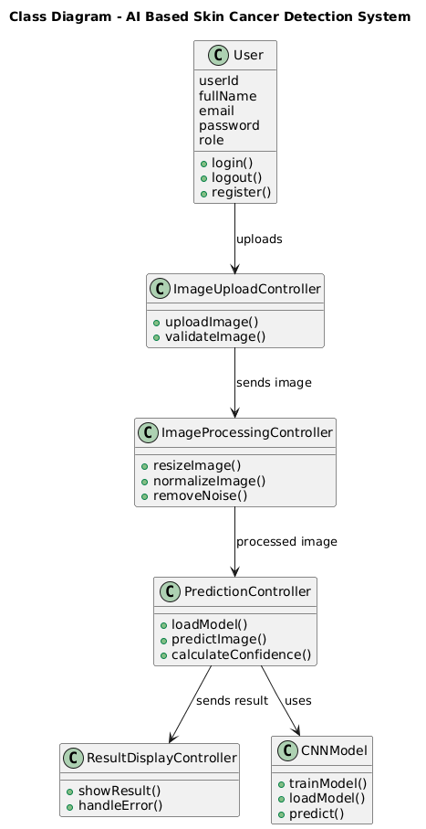
Fig1.1: Class Diagram
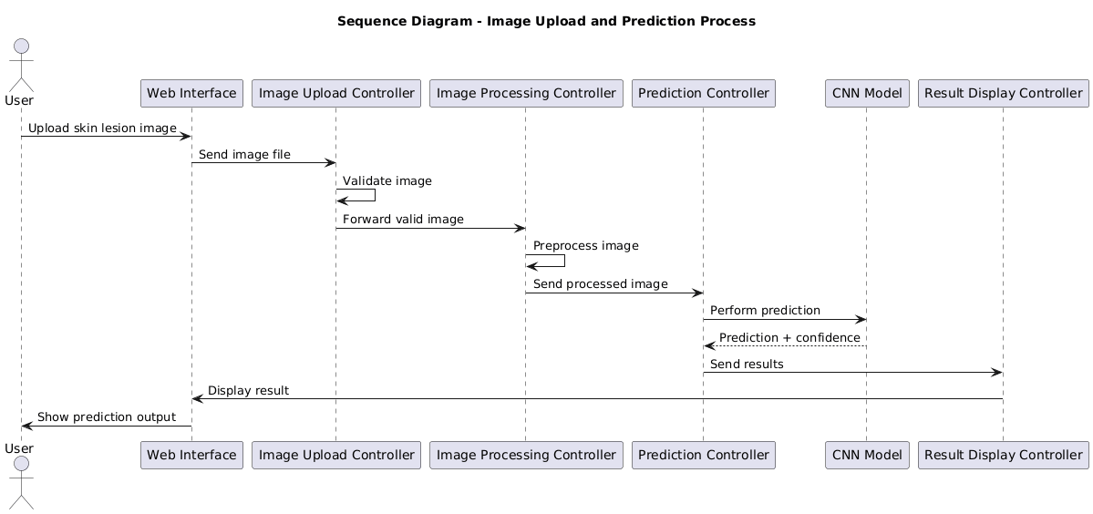
Fig1.2: Sequence Diagram
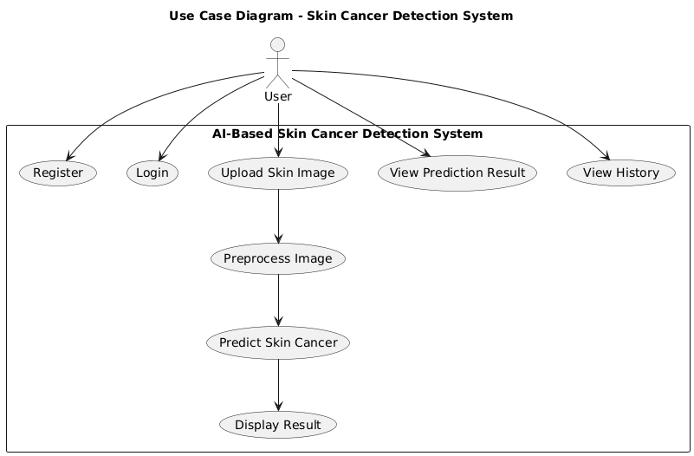
Fig1.3: Use case Diagram

1.5 Coding Conventions
The following coding conventions are followed to ensure code quality and readability:
- Meaningful and descriptive variable and function names
- Consistent indentation and formatting
- Modular code structure with separate files for controllers and utilities
- Proper commenting for complex logic
- Use of standard Python naming conventions (PEP 8)
These conventions help maintain clean, understandable, and maintainable source code throughout the development lifecycle.

- Data Model Schema
The data model of the AI-based Skin Cancer Detection system defines the structure of data storage, organization, and relationships among different entities involved in the application. The conceptual database schema is designed to support user management, image storage, prediction results, and system logging while ensuring data integrity and efficient access.
The system follows a relational database approach, where data is organized into well-defined entities. Each entity represents a real-world object within the system and maintains relationships with other entities to support application functionality.
2.1 User Entity
The User entity stores information related to registered users of the system, such as dermatologists, researchers, or medical students.
Attributes:
- User_ID (Primary Key)
- Full_Name
- Email_Address
- Password
- User_Role
- Account_Creation_Date
Description:
The User entity is responsible for authentication and access control. Each user can upload multiple skin lesion images and view prediction results associated with their account.
2.2 Skin_Lesion_Image Entity
The Skin_Lesion_Image entity stores metadata related to uploaded skin lesion images.
Attributes:
- Image_ID (Primary Key)
- User_ID (Foreign Key)
- Image_Path
- Upload_Date
- Image_Format
- Image_Status
Description:
This entity maintains a record of all images uploaded by users. Each image is linked to a specific user and is processed by the system for classification.
2.3 Prediction_Result Entity
The Prediction_Result entity stores the classification output generated by the CNN model.
Attributes:
- Result_ID (Primary Key)
- Image_ID (Foreign Key)
- Prediction_Label
- Confidence_Score
- Prediction_Date
Description:
This entity records whether a skin lesion is classified as benign or malignant along with the confidence score. Each prediction result is associated with a specific image.
2.4 Model_Details Entity
The Model_Details entity stores information about the trained AI model used in the system.
Attributes:
- Model_ID (Primary Key)
- Model_Name
- Model_Version
- Accuracy
- Training_Dataset
- Last_Updated
Description:
This entity helps track model versions and performance metrics. It supports future model updates and evaluation.
2.5 Entity Relationships
The relationships among the entities are defined as follows:
- One User can upload multiple Skin_Lesion_Images (One-to-Many).
- Each Skin_Lesion_Image can generate one Prediction_Result (One-to-One).
- The Prediction_Result is associated with one Skin_Lesion_Image.
- The Model_Details entity is referenced during the prediction process for record-keeping purposes.
These relationships ensure consistency and traceability of user actions and prediction outcomes.
2.6 Entity Relationship (ER) Diagram
An Entity Relationship (ER) diagram is used to visually represent the conceptual database schema of the system. The ER diagram illustrates entities, their attributes, primary keys, foreign keys, and relationships among them.
The ER diagram clearly shows how users interact with the system, how images are linked to users, and how prediction results are generated and stored. This diagram serves as a blueprint for database implementation and future system expansion.
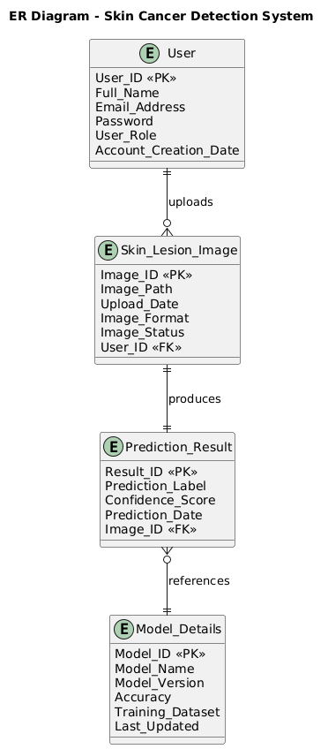
Fig2.1: ER Diagram
- User Interface
The user interface of the AI-based Skin Cancer Detection system is designed with a strong focus on simplicity, usability, and clarity. Since the primary users include dermatologists, medical students, and researchers, the interface is kept intuitive and easy to navigate without requiring technical or AI-related expertise.
3.1 Design Philosophy
The overall design philosophy of the application emphasizes a clean and professional appearance suitable for medical and academic use.
- Color Scheme:
A light and neutral color scheme is used, primarily consisting of white, light blue, and soft gray tones. These colors provide a calm visual experience and are commonly associated with medical applications.
- Font Style:
Simple and readable fonts such as sans-serif fonts are used to ensure clarity and readability across all screen sizes.
- Design Niche:
The design follows a minimalistic approach, avoiding unnecessary graphics and distractions. The focus remains on functionality and ease of interaction.
- Screen Constraints and Responsiveness:
The user interface is designed to be responsive and supports different screen sizes, including desktops, laptops, and tablets. The layout automatically adjusts to varying screen resolutions to ensure a consistent user experience.
3.2 List of Screens / Pages
The system consists of the following main screens:
3.2.1 Login Page
This page allows registered users to log into the system.
Displayed Data:
- Email address
- Password
Controls Used:
- Textbox (Email)
- Password field
- Login button
Input Constraints:
- Email must be in valid format
- Password field cannot be empty
3.2.2 Registration Page
This page allows new users to create an account.
Displayed Data:
- Full name
- Email address
- Password
Controls Used:
- Textbox (Name)
- Textbox (Email)
- Password field
- Register button
Input Constraints:
- All fields are mandatory
- Email must be unique
- Password must meet minimum security requirements
3.2.3 Image Upload Page
This page allows users to upload skin lesion images for analysis.
Displayed Data:
- Image upload option
- Image preview (optional)
Controls Used:
- File upload control
- Submit button
Input Constraints:
- Only image formats (JPG, PNG) are allowed
- File size limit is enforced
- Corrupted files are rejected
3.2.4 Prediction Result Page
This page displays the classification result generated by the AI model.
Displayed Data:
- Prediction label (Benign / Malignant)
- Confidence score
Controls Used:
- Result display panel
- Back or Upload New Image button
Input Constraints:
- Read-only output, no user input required
3.2.5 History Page (Optional)
This page allows users to view their previous prediction records.
Displayed Data:
- List of uploaded images
- Corresponding prediction results and dates
Controls Used:
- Table view
- Navigation buttons
Input Constraints:
- Data displayed is user-specific and read-only
3.3 Working of UI Data Flow
The user interacts with the interface by entering required information or uploading images. The system validates all inputs at the user interface level before sending requests to the backend. Valid data is processed, and results are returned and displayed on the relevant screen. Error messages are shown in case of invalid input or system failure.
3.4 Input Validation and Constraints
To ensure data accuracy and system reliability, the following input constraints are applied:
- Mandatory fields must not be left empty
- Email addresses must follow standard formatting rules
- Uploaded images must be valid and supported formats
- File size and resolution constraints are enforced
- System-generated outputs are displayed in read-only mode

